ATTACHMENT 1 – WITHOUT PREJUDICE CONDITIONS

A. THE DEVELOPMENT

Approved Plans

- Development the subject of this determination notice must be carried out strictly in accordance with the following plans with reference to the recommendations of the reports below:

Plans

Plan Name | Plan Number | Revision | Date | Prepared By
Site Plan | DA 1201 | 2 | 4/6/21 | Fjmt Studio
Basement 05 Plan | DA 20B5 | 1 | 24/9/20 | Fjmt Studio
Basement 04 Plan | DA 20B4 | 1 | 24/9/20 | Fjmt Studio
Basement 03 Plan | DA 20B3 | 1 | 24/9/20 | Fjmt Studio
Basement 02 Plan | DA 20B2 | 2 | 4/6/21 | Fjmt Studio
Basement 01 Plan | DA 20B1 | 2 | 4/6/21 | Fjmt Studio
Lower Ground Plan (Scott St) | DA 20LG | 2 | 4/6/21 | Fjmt Studio
Upper Ground Plan (Terminus St) | DA 20UG | 2 | 4/6/21 | Fjmt Studio
Level 01 Plan – Council Chambers | DA 2001 | 2 | 4/6/21 | Fjmt Studio
Level 02 Plan | DA 2002 | 1 | 24/9/20 | Fjmt Studio
Level 03 Plan | DA 2003 | 1 | 24/9/20 | Fjmt Studio
Level 04 and Level 05 Plan | DA 2004 | 2 | 4/6/21 | Fjmt Studio
Level 06 Plan – Childcare | DA 2006 | 1 | 24/9/20 | Fjmt Studio
Level 07 and Level 08 Plan | DA 2007 | 2 | 4/6/21 | Fjmt Studio
Level 09, Level 10 and Level 11 Plan | DA 2011 | 1 | 24/9/20 | Fjmt Studio
Level 12 Plan - Plant | DA 2012 | 1 | 24/9/20 | Fjmt Studio
Roof Plan | DA 2014 | 2 | 4/6/21 | Fjmt Studio
North Elevation (Scott Street Elevation) | DA 3000 | 1 | 24/9/20 | Fjmt Studio
North Elevation (without Library) | DA 3001 | 1 | 24/9/20 | Fjmt Studio
East Elevation | DA 3002 | 2 | 4/6/21 | Fjmt Studio
West Elevation | DA 3003 | 2 | 4/6/21 | Fjmt Studio
South Elevation (Terminus Street Elevation) | DA 3004 | 2 | 4/6/21 | Fjmt Studio
Section 1 – Library and Civic Plaza | DA 4001 | 2 | 4/6/21 | Fjmt Studio
Section 2 – Tower and Pocket Park | DA 4002 | 1 | 24/9/20 | Fjmt Studio
Section 3 – Tower and Library | DA 4003 | 1 | 24/9/20 | Fjmt Studio
Landscape Terraces and Green Roof Plan | DA 8100 | 2 | 4/6/21 | Fjmt Studio
Landscape and Public Domain Plan | DA 8101 | 2 | 4/6/21 | Fjmt Studio
Landscape and Public Domain Sections | DA 8102 | 2 | 4/6/21 | Fjmt Studio
Specification Notes | PA-MW-C1.02 | 2 | 25/09/20 | Warren Smith and Partners
Existing Survey | PA-MW-C1.03 | 1 | 11/09/20 | Warren Smith and Partners
Sediment and Erosion Control Details | PA-MW-C2.02 | 1 | 11/09/20 | Warren Smith and Partners
Siteworks Key Plan | PA-MW-C4.01 | 2 | 25/09/20 | Warren Smith and Partners
Siteworks Plan Sheet 1 of 2 – Lower Ground | PA-MW-C4.02 | 3 | 25/09/20 | Warren Smith and Partners
Siteworks Plan Sheet 2 of 2 – Upper Ground | PA-MW-C4.03 | 3 | 25/09/20 | Warren Smith and Partners
Siteworks Details | PA-MW-C4.04 | 2 | 25/09/20 | Warren Smith and Partners
Access Driveway Longitudinal Section | PA-MW-C5.01 | 2 | 25/09/20 | Warren Smith and Partners
Access Driveway Cross Section | PA-MW-C5.02 | 2 | 25/09/20 | Warren Smith and Partners
Stormwater Layout Plan | PA-MW-C6.01 | 2 | 25/09/20 | Warren Smith and Partners
Stormwater Pit Schedule | PA-MW-C6.02 | 2 | 14/10/20 | Warren Smith and Partners
Stormwater Catchment Plan | PA-MW-C6.03 | 2 | 25/09/20 | Warren Smith and Partners
Stormwater Typical Drainage Details | PA-MW-C6.04 | 2 | 25/09/20 | Warren Smith and Partners
WSUD Treatment Devices Typical Details | PA-MW-C6.05 | 2 | 25/09/20 | Warren Smith and Partners

Reference Reports

Report Name | Reference | Date | Prepared By
Noise Impact Assessment | 43144-2 | 6 October 2020 | Stantec Australia Pty Ltd
Regulatory Compliance Report | 200984-03 BCA | 23 September 2020 | Mckenzie group
Utility Services Report |  | 6 May 2020 | Warren Smith and Partners
Geotechnical Assessment for Concept Design | 19125312-002-L-Rev 4 | 8 September 2020 | Golder
Heritage Impact Statement |  | 24 September 2020 | NBRS and Partners
Environmentally Sustainable Design Report | 43144-2 | 22 September 2020 | Stantec Australia Pty Ltd
Civil Engineering Services |  | 25 September 2020 | Warren Smith and Partners
Traffic Impact Assessment |  | 28 September 2020 | Ptc.
Operational Waste Management Plan | SO648 | 24/09/2020 | Elephants Foot Recycling Solutions
Pedestrian Wind Environment Study | WE999-02F02(Rev3) | 24/09/2020 | Windtech
Attachment D of Detailed Response to Architectus’ request for additional information (RFI 2 May 2021) |  |  | Fjmt Studio
Attachment D of Detailed Response to Architectus’ request for additional information (RFI 23 December 2020) |  |  | Ptc.

except where modified by the undermentioned conditions and/or the plans/reports that have been submitted in satisfaction of Part 1 of this Development Consent.

Design Modifications

- Amended details and documentation must be submitted to and approved by Council’s Manager of Development Assessment prior to the issue of the first Construction Certificate. These documents must include:

  - Amended civil and stormwater design details that are consistent with the final layout inclusive of the following amendments as requested by Council’s Development Engineers:

    - In addition to the installation of the proposed butterfly grate in Scott Street, an additional grated gully pit must be provided clear of the new driveway with a minimum 1.8m EKI.

    - Full details of how the basement levels are to be drained must be included in the application for a Construction Certificate. Plans must include details of pump out pits, subsoil drainage pipes and pits and grate details for driveways and other entry points.

  - The applicant shall develop a prototype of the façade system for the proposed library building and prepare 1:1 scale VMU (visual mock ups) to demonstrate the functioning of the façade system.

  - Amended architectural and landscape design that incorporate the following amendments requested by Council’s Public Domain and City Design Team:

    - The minimum clear trunk height for tree planting is to be 4m within the public domain, except where the trees are required to mitigate wind impacts, in accordance with the recommendations contained in the Pedestrian Wind Environment Study prepared by Windtech dated 24 September 2020.

    - Provide low planting at the back of kerb along Scott Street, where there are no pedestrian or vehicle crossing or entry points, in accordance with Liverpool Council Public Domain Master Plan.

    - Appropriate treatments to the paths where they cross with vehicle entry/exit points is to be provided along Terminus Street to promote pedestrian priority.

    - A clear solution around cyclist movements is required, and should consider the various uses on the site and anticipated hours of usage for the various buildings.

    - Details around tree planting, including location, heights, canopy spread, and species.

    - Details on material selections nominated for the public domain and landscaped areas.

    - Provide evidence that access through the public domain is compliant and adequately planned and sized.

    - Awnings are required to be incorporated along the Terminus Street frontage to provide weather protection to pedestrians.

    - Evidence that tree locations are optimal and will not provide any safety risks.

    - Detail the proposed paths of travel, access points to buildings, rest areas, and activation zones within the public domain areas, and also the connections to the street network and contribution to the existing public domain.

    - Provide various functional overlays for the public domain areas, such as event scenarios and test-fits. This is to ensure the design for the public domain spaces are fit for purpose, and provide appropriate flexibility from a functional and servicing perspective.

    - Provide detail on materials and finishes to buildings.

Public Art

- Prior to the issue of the first Construction Certificate, a comprehensive Public Art Strategy needs to be submitted to Council’s Manager of Development Assessment for review and approval.

Heritage Interpretation Plan

- A heritage interpretation plan shall be prepared for the site, related to the archaeological remains and the known history of the site. The plan shall be submitted for approval by Council’s Heritage Officer prior to the issue of the first Construction Certificate.

Electrical and Lighting Strategy

- Prior to the first Construction Certificate being issued, a detailed Electrical and Lighting Plan for power and lighting in the public domain and library building must be prepared by a suitably qualified and experienced consultant in accordance with Liverpool City Council Public Domain Master Plan and must be submitted to and approved by Council's Manager City Design and Public Domain Manager.

The plan must include certification by a suitably qualified, practicing lighting engineer or lighting designer to certify that the design complies with City policies and all relevant Australian Standards including AS 1158 and AS4282.

Wayfinding Strategy

- Prior to the issue of the first Construction Certificate, a detailed signage and wayfinding strategy must be submitted to and approved by Council's Manager City Design and Public Domain Manager. The Strategy shall include a suite of custom-designed signs for the public domain which are designed in accordance with any applicable wayfinding specifications.

Utility Services
- All the recommendations issued by Endeavour Energy shall be complied with prior, during, and at the completion of construction, as required in accordance with the recommendations attached to this decision notice.

- All the recommendations issued by Sydney Water shall be complied with prior, during, and at the completion of construction, as required in accordance with the recommendations attached to this decision notice.

- All the conditions issued by Transport for NSW, dated 25 March 2021, shall be complied with prior, during, and at the completion of construction, as required in accordance with the conditions detailed in their correspondence. A copy of the correspondence is attached to this decision notice.

Development in flight paths

- This consent does not authorize the utilization of any cranes associated with the proposed development without a separate application to be lodged and approved.

Compliance with the Environmental Planning & Assessment Act 1979

- The requirements and provisions of the Environmental Planning & Assessment Act 1979 and Environmental Planning & Assessment Regulation 2000, must be fully complied with at all times.

Failure to comply with these legislative requirements is an offence and may result in the commencement of legal proceedings, issuing of ‘on-the-spot’ penalty infringements or service of a notice and order by Council.

Site Development Work

- All aspects of construction shall comply with the applicable Performance Requirements of the National Construction Code. Compliance with the Performance Requirements can only be achieved by:

(a) Complying with the Deemed to Satisfy Provisions; or
(b) Formulating an Alternative Solution, which complies with the Performance Requirements or is shown to be at least equivalent to the Deemed to Satisfy Provision, or a combination of (a) and (b).

Design Integrity Panel

- A Design Integrity Panel is to be convened at the expense of the applicant to undertake a design review of the proposed development:

- A design review is to be convened at the discretion of Council’s Manager of Development Assessment at each of the following stages to ensure that the proposed development achieves the design intent of the DA approved plans in a manner consistent with the advice of the Design Excellence Panel and Public Domain Design Panel:

  - Prior to the determination of any Section 4.55 which modifies the design intent,

  - Prior to the issue of any relevant Construction Certificate, and

  - Prior to the issue of any relevant Occupation Certificate.

- As part of each design review, a Design Integrity Panel is to be convened, made up of at least three (3) members of Council’s Design Excellence Panel. The Panel is to be chaired by the nominated chair of Council’s Design Excellence Panel or his or her nominee.

- At the conclusion of the review, the Design Integrity Panel is to record the outcome of its review and any recommendations within a report or minutes.

- Any recommendations made by the Design Integrity Panel are to be incorporated by the applicant to the satisfaction of the Design Integrity Panel.

- Written confirmation that the proposed development achieves the design intent of the DA approved plans in a manner consistent with the advice of the Design Excellence Panel and Public Domain Design Panel is to be obtained from Design Integrity Panel:

  - Prior to the issue of any relevant Construction Certificate for construction certificate plans, and

  - Prior to the issue of any relevant Occupation Certificate for the completed building works.

The Principal Certifying Authority (PCA) will not issue these certificates unless they have been provided with a copy of this written confirmation from the Design Integrity Panel.

Early Works

- All conditions of DA-906/2019 and any subsequent modification shall be complied with prior to the issue of the first Construction Certificate for the proposed development.

B. PRIOR TO ISSUE OF A CONSTRUCTION CERTIFICATE

The following conditions are to be complied with or addressed prior to issue of a Construction Certificate:

Section 7.12 Payment (Liverpool Contributions Plan 2018 – Liverpool City Centre)

- As a consequence of this development, Council has identified an increased demand for public amenities and public services. The following payment represents 3% of the cost of the development and is imposed in accordance with Section 7.12 of Liverpool Contributions Plan 2018 - Liverpool City Centre.

The total contribution is $4,534,716 and will be adjusted at the time of payment in accordance with the contributions plan.

A breakdown of the contributions payable is provided in the attached payment form.
The Contributions Plan may be inspected online at www.liverpool.nsw.gov.au

Payment must be accompanied by the attached form. The payment must be made prior to the first Construction Certificate.

Provision of Services

- An application to obtain a Section 73 Compliance Certificate under the Sydney Water Act 1994, must be lodged with Sydney Water. To facilitate this, an application must be made through an authorised Water Servicing Coordinator. Please refer to the “building and developing” section of Sydney Water’s web site at www.sydneywater.com.au, or telephone 13 20 92.

Following receipt of the application, a ‘Notice of Requirements’ will detail water and sewer extensions to be built and charges to be paid. Please make early contact with the Coordinator, since building of water/sewer extensions can be time consuming and may impact on other services and building, driveway or landscape design. A copy of the ‘Notice of Requirements’ must be submitted to the PCA.

- Written clearance from Endeavour Energy, stating that electrical services have been made available to the development or that arrangements have been entered into for the provision of services to the development must be submitted to the PCA.

- Prior to the issue of any relevant Construction Certificate, the Principal Certifying Authority shall be satisfied that telecommunications infrastructure may be installed to service the premises which complies with the following:
- The requirements of the Telecommunications Act 1997:
- For a fibre ready facility, the NBN Co’s standard specifications current at the time of installation; and
- For a line that is to connect a lot to telecommunications infrastructure external to the premises, the line shall be located underground.

Unless otherwise stipulated by telecommunications legislation at the time of construction, the development must be provided with all necessary pits and pipes, and conduits to accommodate the future connection of optic fibre technology telecommunications.

Fee Payments

- Unless otherwise prescribed by this consent, all relevant fees or charges must be paid. Where Council does not collect these payments, copies of receipts must be provided. For the calculation of payments such as Long Service Levy, the payment must be based on the value specified with the Development Application/Construction Certificate.

The following fees are applicable and payable:

(a) Damage Inspection Fee – relevant where the cost of building work is $20,000 or more, or a swimming pool is to be excavated by machinery.

(b) Fee associated with Application for Permit to Carry Out Work Within a Road, Park and Drainage Reserve.

(c) Long Service Levy – based on 0.35% of the cost of building work where the costing of the CC is $25,000 or more.

These fees are reviewed annually and will be calculated accordingly.

- All fees associated with a road opening permit required for the connection, extension or amplification of any services within Council’s road reserve must be paid to Council prior to the first Construction Certificate and receipts provided to the PCA. A separate form must be submitted in conjunction with payment of the fees. The fees include the standard road opening permit fee and any restoration fees that may be required as a result of the works.

Cladding

- For all Buildings of Type A and B construction having finishes or claddings that is not compliant with the DtS provisions of the NCC, a fire safety report prepared by an accredited certifier – Fire Safety (previously C10 accreditation), must be submitted to the Principal Certifying Authority prior to issue of any relevant Construction Certificate, demonstrating that the proposed external wall cladding material and system for the building complies with the NCC and relevant Australian Standards. The fire safety report is to include evidence of suitability of all proposed external wall cladding materials as per clause A2.2 of the NCC.

Banned Building Products

- No building products that are banned, or products that are subject to a ban if used in a particular way under the Building Products (Safety) Act 2017 are to be used in the construction of the development.

Crime Prevention Through Environmental Design

- The following Crime Prevention through Environmental Design (CPTED) principles are to be incorporated into the development. Where necessary, plans shall be amended to reflect incorporation of the principles and/or details of such to be submitted to the PCA.

- Basement parking areas shall be a light colour;
- CCTV for the ground level, entry/exit points, car parks, lifts and the exterior of the building.
- ‘Way finding’ signage should be utilised at all major interchanges such as lifts and stair wells;
- Lighting is required to be designed in accordance with the Australian and New Zealand Lighting Standard AS 1158. A lighting maintenance policy should be established. Security lighting should be installed in and around the building, and such shall not impact on any adjoining premises. The lighting should be vandal resistant, especially external lighting;
- Corrugated ramps should be considered to prevent skate boarding activities;
- Glazed tiling, patterned, porous and non solid surfaces reduce the reward for graffiti offenders;
- Access to the basement parking levels relating to the residential component of the building shall be controlled via a security controlled device.

Recommendations of Acoustic Report

- The recommendations provided in the approved acoustic report titled Liverpool Civic Place Phase A Noise Impact Assessment Stage 2 Development Application (Ref: 43144-2) prepared by Stantec Australia Pty Ltd dated 6 October 2020 are to be implemented and incorporated into the design and construction of the development and be shown on plans accompanying any relevant Construction Certificate application.

The construction methodology and plans accompanying the Construction Certificate application and mechanical plant/s and equipment shall be assessed and certified in writing by a suitably qualified acoustic consultant to verify conformance with the requirements of the aforementioned acoustic report.

The written certification from the suitably qualified acoustic consultant shall be submitted to and approved by the PCA prior to the Construction Certificate being issued.

Note: ‘Suitably qualified acoustic consultant’ means a consultant who possesses Australian Acoustical Society membership or are employed by an Association of Australasian Acoustical Consultants (AAAC) member firm.

Construction Noise and Vibration Management Plan (CNVMP)

- A site-specific Construction Noise, Vibration Assessment and Management Plan prepared by a suitably qualified acoustic consultant shall be submitted to and approved by the Principal Certifying Authority (PCA) prior to issue of the first Construction Certificate. The Construction Noise, Vibration Assessment and Management Plan must include an assessment of expected noise impacts and detail feasible work practices to be adopted to avoid, remedy or mitigate construction noise and vibration impacts.

The Construction Noise, Vibration Assessment and Management Plan shall be consistent with the ‘Interim Construction Noise Guideline’ published by the Department of Environment and Climate Change NSW (DECC 2009/265) dated July 2009 and include, but not necessarily be limited to the following information:

  - Identification of nearby residences and other noise sensitive land uses;
  - Assessment of expected noise impacts;
  - Detailed examination of feasible and reasonable work practices that will be implemented to minimise noise impacts;
  - Strategies to promptly deal with and address noise complaints;
  - Details of performance evaluating procedures (for example, noise monitoring or checking work practices and equipment);
  - Methods for receiving and responding to complaints about construction noise;
  - Procedures for notifying nearby residents of forthcoming works that are likely to produce noise impacts; and
  - Reference to relevant licence and consent conditions.

The CNVMP must also describe the relevant stages and phases of construction including work program outlining relevant timeframes for each stage/phase and ongoing noise and vibration management, monitoring and reporting. The CNVMP should be revised at each stage/phase of construction.
The Construction Noise, Vibration Assessment and Management Plan must be made available for inspection when requested by the PCA or Liverpool City Council.

Construction Environmental Management Plan (CEMP)

- Prior to issue of the first Construction Certificate, a Construction Environmental Management Plan (CEMP) for the development must be provided to the Principal Certifying Authority for approval. The environmental site management measures must remain in place and be maintained throughout the period of the development. The CEMP must address all environmental aspects of the development’s construction phases, and include (where relevant), but not be limited to, the following:

- Project Contact Information;
- Site Security Details;
- Timing and Sequencing Information;
- Site Soil and Water Management Plan;
- Dust Control Plan;
- Air Monitoring;
- Health and Safety Plan;
- Waste Management Plan;
- Incident management Contingency; and
- Unexpected Finds Protocol.
The CEMP must also describe the relevant stages and phases of construction including work program outlining relevant timeframes for each stage/phase and ongoing environmental management, monitoring and reporting. The CEMP should be revised at each stage/phase of construction.

The CEMP must be kept on site for the duration of the works and must be made available to Council Officers upon request.

Traffic Management

- A revised Local Area Traffic Management Plan (LATMP) prohibiting all right turn movements in to and from Scott Street in to the new driveway to the site (off Scott Street), as per the traffic report section 7.1 page 32 (28 September 2020), needs to be submitted to Council’s Traffic and Transport Section and to the Liverpool Pedestrian Active Transport and Traffic Committee for endorsement.

The revised LATPM will also need to incorporate the proposed ‘Shared Zone’ on the access to the development site in detail, including pedestrian crossing across Scott Street to access the site and other treatments that may be required along the pedestrian path on both Scott Street and Terminus Street surrounding the site, provision for buses including bus stops and other amenity close to the site.

The revised LATPM needs to be submitted to Council’s Traffic and Transport Section for review and endorsement by Liverpool Council Traffic Committee, prior to the issue of the first Construction Certificate.

- Detailed design plans of the driveway, ramps, aisles, loading bays and parking spaces, footpath paving, street lighting, sign and line marking scheme, demonstrating that the design has been carried out in accordance with RMS Guidelines, DCP and AS: 2890. This is to be supported by swept path analysis.

Details to be provided on plans and approved by Council prior to the issue of any relevant Construction Certificate. The drawings must be certified by a qualified traffic engineer that the designs comply with the requirements of the DCP and Australian Standards.

Access

- Access must be provided to the development for people with a disability in accordance with the relevant requirements of the Building Code of Australia, Disability (access to Premises – Buildings) Standard 2010 and Australian Standard – AS1428.1 (2009), Design for Access and Mobility – General requirements for new building work, to the satisfaction of the Certifying Authority.

S138 Roads Act – Minor Works in the public road

- Prior to the issue of any relevant Construction Certificate, a S138 Roads Act application/s, including payment of fees shall be lodged with Liverpool City Council, as the Roads Authority for any works required in a public road. These works may include but are not limited to the following:

- Vehicular crossings (including kerb reinstatement of redundant vehicular crossings)
- Road opening for utilities and stormwater (including stormwater connection to Council infrastructure)
- Road occupancy or road closures
- Tree protection, tree pruning and/or tree removal and replanting

All works shall be carried out in accordance with the Roads Act approval, the development consent including the stamped approved plans, and Liverpool City Council’s specifications.

Note:

1. Approvals may also be required from the Roads and Maritime Service (RMS) for classified roads.

Liverpool CBD – Street Lighting Upgrade

- The applicant/developer shall upgrade street lighting system for entire frontage of the development including any side streets. The street light pole shall be multi-function pole including all necessary accessories. The specification and accessories details are to be obtained from Infrastructure and Environment Group of Council. The applicant/developer shall engage services of Endeavour Energy accredited ASP Level 3 service provider to prepare electrical design and obtain certification from Endeavour Energy. The electrical design shall include undergrounding of existing aerial power lines and communication cables for entire frontage of the development including frontage to side streets. The approved design shall be submitted to Council for review and approval prior to any relevant Construction Certificate.

Liverpool CBD – Communication Conduits

- The applicant/developer shall also supply and install two 50mm white communication conduit with draw wires approximately 300mm behind kerb and gutter connecting multifunction poles. Details can be obtained from Infrastructure and Environment Group of Council. Please contact the Coordinator – Roads and Transport on 1300 36 2170.

Liverpool CBD – Footpath Paving and Landscaping Works

- Periphery Type/ Core Type paving shall be installed along all street frontages, as part of this development. Footpath paving and Landscaping works shall be strictly in accordance with the Liverpool CBD Street Tree and Landscape Strategy 2005 and The Liverpool CBD Streetscape and Paving Guidelines 2005.

Detailed plans are required to be submitted to and approved by Council prior to the issue of any relevant Construction Certificate, showing the proposed tree locations, species and planting sizes, paving location and layout, including references to the relevant details and specifications as contained in the abovementioned documents.

To ensure that the street tree planting size, quantity and quality is maintained throughout the Liverpool CBD, please contact Council’s Land Development Section on 1300 36 2170 for further information.

A Section 138 Roads Act Approval for all works within Council’s road reserve will be required.

S138 Roads Act – Minor Works in the public road

- Prior to the issue of any relevant Construction Certificate for building or subdivision works, the Certifying Authority shall ensure that a Section 138 Roads Act application, including the payment of application and inspection fees, has been lodged with, and approved by Liverpool City Council (being the Roads Authority under the Roads Act), for provision of stormwater drainage works, footpath and roadworks in Scott Street & Terminus Street.

Engineering plans are to be prepared in accordance with the development consent, Liverpool City Council’s Design Guidelines and Construction Specification for Civil Works, Austroad Guidelines and best engineering practice.

Note:

1. Where Liverpool City Council is the Certifying Authority for the development the Roads Act approval for the above works may be issued concurrently with the Construction Certificate.

Stormwater Concept Plan

- A stormwater drainage system shall be provided generally in accordance with the concept plan/s lodged for development approval, prepared by Warren Smith & Partners P/L, reference number PA-MW-C, revision 1 & 2, dated 25/9/2020.

- The proposed development must be designed so as not have an adverse impact on the stormwater runoff from upstream or adjoining properties.

- Engineering plans and supporting calculations for the stormwater drainage system are to be prepared by a suitably qualified engineer and shall accompany the application for a Construction Certificate. The plan shall indicate the method of disposal of all stormwater and must include rainwater tanks, existing ground levels, finish surface levels and sizes of all pipes.

- Prior to the issue of the first Construction Certificate the Certifying Authority shall ensure that the stormwater drainage system for the whole development has been designed in accordance with Liverpool City Council’s Design Guidelines and Construction Specification for Civil Works.

Stormwater Discharge – Basement Car parks

- Prior to the issue of the first Construction Certificate the Certifying Authority shall ensure that the stormwater drainage system for the basement car park has been designed in accordance with the requirements for pumped systems in AS3500.3:2003 and Council’s Stormwater Drainage Design Specifications for pump out systems for basement carparks.

Water Sensitive Urban Design

- Water Sensitive Urban Design (WSUD) principles shall be incorporated in the stormwater design as indicated in stormwater management report (Section 5 and 6 of Civil Engineering Service Report dated 25 September 2020 prepared by Warren Smith & Partners). The stormwater design shall include all engineering details relevant to collection and disposal of stormwater, existing site levels, finished levels, pipe sizes and grades and water quality treatment trains.

No loading on easements

- Prior to the issue of any relevant Construction Certificate the Certifying Authority shall ensure that the foundations of proposed structures adjoining the drainage and/ or services easement have been designed clear of the zone of influence.

Water Quality

- Prior to the issue of the first Construction Certificate the Certifying Authority shall ensure that details of a stormwater pre-treatment system have been provided on the stormwater plans and that the design meets pollutant retention criteria in accordance Council’s Development Control Plan.

The Construction Certificate must be supported by:

- Specification & installation details of the stormwater pre-treatment system
- The approval of an operation and maintenance manual/ schedule for the stormwater pre-treatment system

A copy of the approved operation and maintenance manual/ schedule shall be submitted to Liverpool City Council with notification of the Construction Certificate issue.

Retaining Walls on Boundary

- All retaining walls shall be of masonry construction and must be wholly within the property boundary, including footings and agricultural drainage lines. Construction of retaining walls or associated drainage works along common boundaries shall not compromise the structural integrity of any existing structures.

Where a retaining wall exceeds 600mm in height, the wall shall be designed by a practicing structural engineer and a construction certificate must be obtained prior to commencement of works on the retaining wall.

Access, Car Parking and Manoeuvring – General

- Prior to the issue of any relevant Construction Certificate, the Certifying Authority shall ensure that vehicular access, circulation, manoeuvring, pedestrian and parking areas associated with the subject development are in accordance with AS 2890.1, AS2890.2, AS2890.6 and Liverpool City Council’s Development Control Plan.

- Prior to the issue of any relevant Construction Certificate the Certifying Authority shall ensure that:

- Off street access and parking complies with AS2890.1,
- Sight Distance at the street frontage has been provided in accordance with AS 2890.1,
- All cars can enter and exit the site in a forward direction

Dilapidation Report

- Prior to the Commencement of Works a dilapidation report of all infrastructure fronting the development in Scott Street and Terminus Street is to be submitted to Liverpool City Council. The report is to include, but not limited to, the road pavement, kerb and gutter, footpath, services and street trees and is to extend 10m either side of the development.

Dilapidation Report Private Property (Excavation)

- A full dilapidation survey and report on the visible and structural condition of all neighbouring structures within the ‘zone of influence’ of the required excavations must be submitted to the Certifying Authority for approval prior to the issue of any relevant Construction Certificate. The zone of influence is to be defined as the horizontal distance from the edge of the excavation face to twice the excavation depth.

The dilapidation report and survey is to be prepared by a consulting structural/geotechnical engineer agreed to by both the applicant and the owner of any affected adjoining property.

All costs incurred in achieving compliance with this condition shall be borne by the person entitled to act on this Consent.

In the event that access for undertaking the dilapidation survey is denied by an adjoining owner, the applicant MUST DEMONSTRATE, in writing, to the satisfaction of Council that all reasonable steps have been taken to obtain access and advise the affected property owner of the reason for the survey and that these steps have failed. Written concurrence must be obtained from Council in such circumstances.

Note: This documentation is for record keeping purposes only, and may be used by the developer or affected property owner to assist in any action required to resolve any dispute over damage to adjoining properties arising from the works. It is in the applicant’s and adjoining owner’s interest for it to be as full and detailed as possible.

Reflectivity

- The Principal Certifier must ensure that the visible light reflectivity from building materials used on the facade of the building does not exceed 20% prior to issue of any relevant Construction Certificate.

C. PRIOR TO WORKS COMMENCING

The following conditions are to be complied with or addressed prior to works commencing on the subject site/s:

Building Work

- Building work shall not commence prior to the issue of the relevant Construction Certificate. Building work as defined under Section 6.1 of the EP&A Act means any physical activity involved in the erection of a building and includes but is not limited to, the placement of any site shed/s or builders facilities, site grading, retaining walls, excavation, cutting trenches, installing formwork and steel reinforcement or, placing of plumbing lines.

- Prior to the commencement of any building works, the following requirements must be complied with:

- A Construction Certificate must be obtained from the Council or an accredited certifier, in accordance with the provisions of the Environmental Planning & Assessment Act 1979.

- Where a Construction Certificate is obtained from an Accredited Certifier, the applicant shall advise Council of the name, address and contact number of the Accredited Certifier, in accordance with Section 81A (4) of the Act.

- A copy of the Construction Certificate, the approved development consent plans and consent conditions must be kept on the site at all times and be made available to the Council officers and all building contractors for assessment.

- A Principal Certifying Authority (PCA) must be appointed to carry out the necessary building inspections and to issue an occupation certificate; and

- The PCA must advise Council of the intended date to commence work which is the subject of this consent by completing a notice of commencement of building works or subdivision works form, available from Council’s Customer Service Centre. A minimum period of two (2) working days’ notice must be given.

Site Facilities

- Adequate refuse disposal methods and builders storage facilities shall be installed on the site. Builders’ wastes, materials or sheds are not to be placed on any property other then that which this approval relates to.

Site Notice Board

- A sign must be erected in a prominent position on the premises on which work is to be carried out. The sign is to be maintained during work, and removed at the completion of work. The sign must state:

- The name, address and telephone number of the principal certifying authority for the work; and

- The name of the principal contractor (if any) for any building work and a telephone number on which that person may be contacted outside working hours; and

- Unauthorised entry to the premises is prohibited.

Notification of Service Providers

- The approved development must be approved through the ‘Sydney Water Tap in’ service to determine whether the development will affect any Sydney Water wastewater and water mains, stormwater drains and/or easements, and if any requirements need to be met. A receipt must be provided to Council.

Please refer to the website www.sydneywater.com.au for more information.

Waste Classification

- Prior to the exportation of waste (including fill or soil) from the site, the material shall be classified in accordance with the provisions of the POEO Act 1997, POEO Waste Regulation 2014 and NSW EPA 'Waste Classification Guideline’ (dated November 2014) The classification of the material is essential to determine where the waste may be legally taken. The POEO Act provides for the commission of an offence for both the waste owner and transporters if waste is taken to a place that cannot lawfully be used as a waste facility for the particular class of waste. For the transport and disposal of industrial, hazardous or Group A liquid and non-liquid waste advice should be sought from the DECCW (EPA).

Environmental Management

- Adequate soil and sediment control measures shall be installed and maintained. Furthermore, suitable site practices shall be adopted to ensure that only clean and unpolluted waters are permitted to enter Council’s stormwater drainage system during construction/demolition. Measures must include, as a minimum:

- Siltation fencing;

- Protection of the public stormwater system; and

- Site entry construction to prevent vehicles that enter and leave the site from tracking loose material onto the adjoining public place.

Sediment and Erosion Control

- Prior to commencement of works sediment and erosion control measures shall be installed in accordance with the approved Construction Certificate and to ensure compliance with the Protection of the Environment Operations Act 1997 and Landcom’s publication “Managing Urban Stormwater – Soils and Construction (2004)” – also known as “The Blue Book”.

The erosion and sediment control measures shall remain in place and be maintained until all disturbed areas have been rehabilitated and stabilised.

Traffic Control Plan

- Prior to commencement of works a Traffic Control Plan including details for pedestrian management, shall be prepared in accordance with AS1742.3 “Traffic Control Devices for Works on Roads” and the Roads and Traffic Authority’s publication “Traffic Control at Worksites” and certified by an appropriately accredited Roads and Traffic Authority Traffic Controller.

Traffic control measures shall be implemented during the construction phase of the development in accordance with the certified plan. A copy of the plan shall be available on site at all times.

Note:

1. A copy of the Traffic Control Plan shall accompany the Notice of Commencement to Liverpool City Council.

Visible signage identifying key personnel

- Clearly visible signage with the Site or Construction Managers name and contact details are to be erected on the sites fencing in a prominent position along the perimeter of the building site so that any community concerns can be adequately addressed.

The signage will contain the following wording or similar: “For enquires, complaints or emergencies relating to this site at any time please contact ……”.

The signs are to remain erected for the duration of construction works.

Heritage

- No works are to commence on the Council Administration building until approvals have been sought from Heritage NSW for the disturbance and salvage of the archaeological remains on site.

Ecologically Sustainable Development

- Prior to commencement of construction, details are to be provided to confirm that the building has been designed to achieve a minimum 5 Star Green Star Design and As Built outcome.

Green Roofs

- Prior to the issue of any relevant Construction Certificate, structural and waterproofing certifications for the green roof are to be submitted to and approved by the Principal Certifying Authority.

D. DURING CONSTRUCTION

The following conditions are to be complied with or addressed during construction:

Inspections

- The building works must be inspected by the Principal Certifying Authority, in accordance with the Environmental Planning & Assessment Act 1979 and clause 162A of the Environmental Planning & Assessment Regulation 2000, to monitor compliance with the relevant standards of construction, Council’s development consent and the construction certificate.

- The Principal Certifying Authority must specify the relevant stages of construction to be inspected and a satisfactory inspection must be carried out, to the satisfaction of the Principal Certifying Authority, prior to proceeding to the subsequent stages of construction or finalisation of the works.

Identification Survey Report

- The building and external walls are not to proceed past ground floor/reinforcing steel level until such time as the PCA has been supplied with an identification survey report prepared by a registered surveyor certifying that the floor levels and external wall locations to be constructed, comply with the approved plans, finished floor levels and setbacks to boundary/boundaries. The slab shall not be poured, nor works continue, until the PCA has advised the builder/developer that the floor level and external wall setback details shown on the submitted survey are satisfactory.

In the event that Council is not the PCA, a copy of the survey shall be provided to Council within three (3) working days. On placement of the concrete, works again shall not continue until the PCA has issued a certificate stating that the condition of the approval has been complied with and that the slab has been poured at the approved levels.

Excavation Works

- In the event the development involves an excavation that extends below the level of the base of the footings of a building, structure or work (including any structure or work within a road or rail corridor) on adjoining land, the person having the benefit of the development consent must, at the persons own expense:

- Protect and support the building, structure or work from possible damage from the excavation, and
- where necessary, underpin the building, structure or work to prevent any such damage.
- a and b above does not apply if the person having the benefit of the development consent owns the adjoining land or the owner of the adjoining land has given consent in writing to that condition not applying.
- Retaining walls or other approved methods necessary to prevent the movement of excavated or filled ground, together with associated subsoil drainage and surface stormwater drainage measures, shall be designed strictly in accordance with the manufacturer’s details or by a practising structural engineer.

Facilities

- Toilet facilities must be available or provided at the work site and must be maintained until the works are completed at a ratio of one toilet plus one additional toilet for every 20 persons employed at the site.

Each toilet must:

- be a standard flushing toilet connected to a public sewer, or

- have an on-site effluent disposal system approved under the Local Government Act 1993, or

- be a temporary chemical closet approved under the Local Government Act 1993.

Major Filling/ Earthworks

- All earthworks shall be undertaken in accordance with AS 3798 and Liverpool City Council’s Design Guidelines and Construction Specification for Civil Works.

The level of testing shall be determined by the Geotechnical Testing Authority/Superintendent in consultation with the Principal Certifying Authority.

Contamination

- The development, including all civil works and demolition, must comply with the requirements of the Contaminated Land Management Act, 1997, State Environmental Planning Policy No. 55 – Remediation of Land, and Managing Land Contamination – Planning Guidelines (Planning NSW/EPA 1998).

- All fill introduced to the site must undergo a contaminated site assessment. This assessment may consist of either:

- a full site history of the source of the fill (if known) examining previous land uses or geotechnical reports associated with the source site to determine potential contamination as per the NSW EPA Waste Classification Guidelines (dated November 2014), or

- clearly indicate the legal property description of the fill material source site;

- provide a classification of the fill material to be imported to the site in accordance with the NSW EPA Waste Classification Guidelines (dated November 2014).

- a chemical analysis of the fill where the site history or a preliminary contamination assessment indicates potential contamination or contamination of fill material; and

- must provide Council with copies of validation certificate verifying the material to be used is free of contaminants and fit for purpose re use in residential, commercial or industrial use.

- Records of the following must be submitted to the principal certifying authority monthly and at the completion of earth works:

- The course (including the address and owner of the source site), nature and quantity of all incoming loads including the date, the name of the carrier, and the vehicle registration;

- The results of a preliminary contamination assessment carried out on any fill material used in the development.

- The results of any chemical testing of fill material.

Unidentified Contamination

- Any new information which comes to light during remediation, demolition or construction works which has the potential to alter previous conclusions about site contamination and remediation must be notified to Council and the accredited certifier immediately after discovery. A separate application under the EP&A Act shall be made for any proposed works outside the scope of the approved development consent.

Air Quality

- Dust screens shall be erected and maintained in good repair around the perimeter of the subject land during land clearing, demolition, and construction works.

- All vehicles involved in the delivery, demolition or construction process departing from the property shall have their loads fully covered before entering the public roadway.

Erosion Control

- Vehicular access to the site shall be controlled through the installation of wash down bays or shaker ramps to prevent tracking of sediment or dirt onto adjoining roadways. Where any sediment is deposited on adjoining roadways is shall be removed by means other than washing. All material is to be removed as soon as possible and the collected material is to be disposed of in a manner which will prevent its mobilization.

Water Quality

- All topsoil, sand, aggregate, spoil or any other material shall be stored clear of any drainage line, easement, water body, stormwater drain, footpath, kerb or road surface and there shall be measures in place in accordance with the approved erosion and sediment control plan.

Pollution Control

- Building operations such as brick cutting, mixing mortar and the washing of tools, paint brushes, form-work, concrete trucks and the like shall not be performed on the public footway or any other locations which may lead to the discharge of materials into Council’s stormwater drainage system.

- The developer is to maintain all adjoining public roads to the site in a clean and tidy state, free of excavated “spoil” material.

Hoardings

- If the work is likely to cause pedestrian or vehicular traffic in a public area to be obstructed or rendered inconvenient; or if craning of materials is to occur across a public area or road reserve area a construction hoarding must be erected to prevent any substance from, or in connection with the construction site, falling onto a public area:

Such hoarding or barrier must be designed and erected in accordance with Council’s guidelines on hoarding construction. Relevant application under the Roads Act approval must be completed and fees paid prior to the construction of a hoarding on Council road reserve area.

- The following hoarding requirements must be complied with:

- where feasible graphics must be provided illustrating Liverpool's history developed in consultation with Council's Public Art Officer;

- no third-party advertising is permitted to be displayed on the subject hoarding/ fencing; and

- the construction site manager must be responsible for the removal of all graffiti from any construction hoardings or the like within the construction area within 48 hours of its application.

- Lifting or craning materials over a public footway or roadway is not permitted unless a “B” class construction hoarding has been installed in compliance with Work Cover authority requirements.

- The applicant/ builder shall be responsible to report to the Council any damage to Council’s footpath and road carriageway as a consequence of demolition or excavation or building activities or delivery/ departure of materials associated with this site. The damage shall be reported to Council as soon as the damage becomes apparent to the builder/ site manager. Arrangements to the satisfaction of Council are to be made for making safe by temporary repairs to the public way until permanent restoration and repair can be organised with Council.

Hours of Construction Work and Deliveries

- Construction work/civil work/demolition work, including the delivery of materials, is only permitted on the site between the hours of 7:00am to 6:00pm Monday to Friday and 8:00am to 1:00pm Saturday. No work will be permitted on Sundays or Public Holidays, unless otherwise approved by Council.

Security Fence

- A temporary security fence to WorkCover Authority requirements is to be provided to the property during the course of construction.

Note. Fencing is not to be located on Council’s reserve area.

General Site Works

- Building operations such as brick cutting, mixing mortar and the washing of tools, paint brushes, form-work, concrete trucks and the like shall not be performed on the public footway or any other locations which may lead to the discharge of materials into Council’s stormwater drainage system.

- Erosion and sediment control measures shall remain in place and be maintained until all disturbed areas have been rehabilitated and stabilised.

- All topsoil, sand, aggregate, spoil or any other material shall be stored clear of any drainage line, easement, water body, stormwater drain, footpath, kerb or road surface and there shall be measures in place in accordance with the approved erosion and sediment control plan.

- The developer is to maintain all adjoining public roads to the site in a clean and tidy state, free of excavated “spoil” material.

- Alterations to the natural surface contours must not impede or divert natural surface water runoff, so as to cause a nuisance to adjoining property owners.

- The development, including construction, shall not result in any increase in sediment deposition into any water body, wetland, bushland or environmentally significant land.

- All dangerous and/ or hazardous material shall be removed by a suitably qualified and experienced contractor licensed by WorkCover NSW. The removal of such material shall be carried out in accordance with the requirements of WorkCover NSW. The material shall be transported and disposed of at a licensed waste facility to receive the waste in accordance with NSW EPA requirements.

Car Parking Areas

- Car parking spaces and driveways must be constructed of a minimum of two coat finish seal or better. The spaces must be clear of obstructions and columns, permanently line marked and provided with adequate manoeuvring facilities. The design of these spaces must comply with Council’s DCP 2008, and Australian Standard 2890.1 Parking Facilities – Off Street Car Parking.

- All car parking areas to be appropriately line marked and sign posted in accordance with the approved plans. All customer/visitor/staff parking areas are to be clearly signposted limiting car parking for customers/visitors/staff only. The applicant is to cover the costs of installation and maintenance of the signage.

- The on-site parking spaces shown in the approved plans must be identified in accordance with A.S.2890.1 Parking Facilities – Off-Street Car Parking.

- Directional signage indicating the location of customer parking, “in” and “out” crossings and directional arrows are to be provided in accordance with the approved plans.

Waste Management Plan

- The Waste Management Plan submitted to and approved by Council must be adhered to at all times throughout all stages of the development. Supporting documentation (receipts/dockets) of waste/recycling/disposal methods carried out, is to be kept and must be produced upon the request of Council or any other authorised officer.

Note: Any non-compliance with this requirement will result in penalties being issued.

External

- Switchboards for utilities shall not be attached to the street and/or road elevations of the development.

- Any external lighting is to incorporate full cut-off shielding and is to be mounted so as to not cause any glare or spill over light nuisance within the development, neighbouring properties or road users.

- The reflectivity index of glass used in the external facade of the building is not to exceed 20%.

Ventilation

- To ensure that adequate provision is made for ventilation of the building, the design, construction, installation and commissioning of the mechanical ventilation systems(s) shall be carried out in accordance with Australian Standard 1668 Set - 2016.

- The mechanical exhaust discharge point shall be designed and installed by an appropriately qualified person and shall be positioned to comply with AS 1668 Part 2, Section 3.7.

Construction Noise

- Construction noise shall not exceed the management levels defined within the Interim Construction Noise Guideline published by the NSW Department of Environment and Climate Change dated July 2009.

- Construction activities, including operation of vehicles, shall be conducted so as to avoid unreasonable noise or vibration and cause no interference to adjoining or nearby occupations. Special precautions must be taken to avoid nuisance in neighbouring residential areas, particularly from machinery, vehicles, warning sirens, public address systems and the like. In the event of a noise or vibration problem arising at the time, the person in charge of the premises shall when instructed by Council, cause to be carried out, an acoustic investigation by an appropriate acoustical consultant and submit the results to Council. If required by Council, the person in charge of the premises shall implement any or all of the recommendations of the consultant and any additional requirements of Council to Council’s satisfaction.

Erosion and sediment control

- Erosion and sediment control measures shall remain in place and be maintained until all disturbed areas have been rehabilitated and stabilised.

Drainage Connection

- Prior to the connection of private drainage to Council’s drainage system, an inspection is to be carried out by Liverpool City Council’s Development Engineering Unit. A fee will be charged in accordance with Council’s adopted Fees and Charges, and is to be paid prior to the inspection.

Construction Noise and Vibration Management Plan and CEMP

- The approved site-specific Construction Noise and Vibration Management Plan and CEMP prepared and approved by the PCA shall be implemented, adhered to and maintained at all times during the construction period.

Construction Traffic Management Plan

- The site-specific CTMP approved by Council shall be implemented, adhered to and maintained at all times during the construction period.

E. PRIOR TO ISSUE OF OCCUPATION CERTIFICATE

The following conditions are to be complied with or addressed prior to issue of either an Interim or Final Occupation Certificate by the Principal Certifying Authority:

Land Consolidation/Registration

- All separate lots must be consolidated. The applicant shall provide evidence that the linen plan, for the required lot consolidation endorsed by Council, has been registered with the LPI Service. This is to be provided to Council prior to the release of any OC.

Certificates

- The premises must not be utilised until an Occupation Certificate is issued by the Principal Certifying PCA. Copies of all documents relied upon for the issue of the OC must be attached to the OC and registered with Council.

- A single and complete Fire Safety Certificate, certifying the installation and operation of all of the fire safety measures within the building must be submitted to Council with the Occupation Certificate.

- Details of critical stage inspections carried out by the principal certifying authority together with any other certification relied upon must be provided to Council with the occupation certificate.

- The Principal Certifying Authority (Building) and/or the Accredited Certifier (Subdivision) shall ensure that all compliance certificates required by this development consent are referenced to the condition consent number. The Compliance Certificate is to state that the works as constructed comply fully with the required condition of consent being acted on by the certifier.

- Prior to issuing an occupation certificate the principal certifier must be satisfied that suitable evidence has been provided to demonstrate that the external wall cladding material and system in the relevant buildings the subject of the occupation certificate is consistent with the consent documentation, NCC and relevant Australian Standards.

Service Providers

- A Section 73 Compliance Certificate under the Sydney Water Act 1994 must be submitted to the PCA.

- Notification of arrangement for the development from Endeavour Energy shall be submitted to Council.

- Prior to the issue of an Occupation Certificate, written certification from all relevant service providers that the telecommunications infrastructure is installed in accordance with:

- The requirements of the Telecommunications Act 1997:

- For a fibre ready facility, the NBN Co’s standard specifications current at the time of installation; and

- For a line that is to connect a lot to telecommunications infrastructure external to the premises, the line shall be located underground.

Unless otherwise stipulated by telecommunications legislation at the time of construction, the development must be provided with all necessary pits and pipes, and conduits to accommodate the future connection of optic fibre technology telecommunications

Cladding

- Prior to issuing any occupation certificate, the principal certifier must be satisfied that suitable evidence has been provided to demonstrate that the external wall cladding material and system is consistent with the consent documentation, NCC and relevant Australian Standards.

Road Works and Road Reserve Works

- All traffic related works including intersection improvements works, line-marking and signposting are to be completed to the satisfaction of Council.

- Street lighting on Scott Street and Terminus Street shall be completed to Council’s and Endeavour Energy’s satisfaction.

Landscaping

- Upon completion of the approved landscape works associated with the development and prior to the issue of any OC, an Implementation Report is to be submitted to the PCA attesting to the satisfactory completion of the landscape works in accordance with the approved landscape plan. The report is to be prepared by a suitably qualified person.

Redundant Layback

- Redundant laybacks shall be removed and replaced with kerb and gutter as required to Liverpool City Council specifications.

Recommendations of Acoustic Report

- Upon completion of works and prior to the issue of an Interim or Final Occupation Certificate, written certification prepared by a suitably qualified acoustic consultant shall be submitted to and approved by the PCA. The written certification prepared by the suitably qualified acoustic consultant shall confirm that the development complies with all requirements and recommendations detailed within the approved acoustic report. The acoustic consultant shall confirm that the development or use is capable of operating in accordance with the relevant criteria.

Public Art

- Prior to the issue of the relevant Occupation Certificate, all works proposed in the endorsed public art strategy required by Condition 3, shall be completed to the satisfaction of Council.

Heritage Interpretation Plan

- Evidence of implementation of the endorsed heritage interpretation plan required by Condition 4, shall be received and approved by Council’s Heritage Officer prior to issue of any Occupation Certificate.

Electrical and Lighting

- The public domain lighting works are to be completed in accordance with the electrical and lighting strategy required by Condition 5, before any Occupation Certificate is issued in respect of the development.

Wayfinding

- Prior to the issue of any Occupation Certificate, all works proposed in the endorsed wayfinding strategy required by Condition 6, shall be completed to the satisfaction of Council.

Air Conditioners

- All air handling, evaporative cooling, humidifying, warm water and water cooling systems installed on the premises shall comply with the Public Health Act 2010, Public Health Regulation 2012 and AS/NZS 3666:2011-Air Handling and water systems of building - Microbial Control:

- All water cooling and warm water systems shall be designed, constructed and installed in accordance with AS 3666.1:1995, the Public Health Act 2010 and Public Health Regulation 2012 before being commissioned.

- All cooling towers and warm water systems shall be operated and maintained in accordance with AS 3666.2:1995, (or AS 3666.3:2000 subject to prior notification to Council) the Public Health Act 2010, Public Health Regulation 2012.

- A true copy of the annual certificate as stipulated in Clause 9(2) of the Public Health (Microbial) Regulation 2012 that certifies the effectiveness of the process of disinfection used for the water cooling system, shall be submitted to Council prior to the period ending 30 June each year.

- The owner or occupier of the building shall be advised of the need to register and provide particulars of any water cooling, and warm-water systems as required under the provisions of the Public Health Act, 2010 and Regulation thereunder. Registration forms are available from Council.

Mechanical Ventilation Certification

- Certificates of design compliance and system performance for the proposed mechanical ventilation system shall be provided to the PCA, certifying the design, and upon commissioning of the mechanical ventilation system(s), certifying performance. The certificate of performance shall be issued to the certifying authority and be accompanied by details of the test carried out in respect of: -

(a) Ventilation
(b) Acoustics

Notification of Regulated Water System/s

- The occupier of the premises is to notify Liverpool City Council in regards to the regulated system/s installed. The PCA is to ensure a Liverpool City Council approved registration form is completed and submitted to the Council with the relevant fee.

Liverpool City Council clearance – Roads Act/ Local Government Act

- Prior to the issue of an Occupation Certificate, the Principal Certifying Authority shall ensure that all works associated with a S138 Roads Act approval or S68 Local Government Act approval have been inspected and signed off by Liverpool City Council.

Works as executed – General

- Prior to the issue of an Occupation Certificate, works-as-executed drawings and compliance documentation shall be submitted to the Principal Certifying Authority in accordance with Liverpool City Council’s Design Guidelines and Construction Specification for Civil Works.

An original set of works-as-executed drawings and copies of compliance documentation shall also be submitted to Liverpool City Council with notification of the issue of the Occupation Certificate where Council is not the Principal Certifying Authority.

Stormwater Compliance

- Prior to the issue of an Occupation Certificate the Principal Certifying Authority shall ensure that the:

- Stormwater pre-treatment system/s

- Basement Carpark pump-out system

- Have been satisfactorily completed in accordance with the approved Construction Certificate and the requirements of this consent.

- Have met the design intent with regard to any construction variations to the approved design.

- Any remedial works required to been undertaken have been satisfactorily completed.

Details of the approved and constructed system/s shall be provided as part of the Works-As-Executed drawings.

Local Area Traffic Management Plan

- Prior to the issue of the first Occupation Certificate, the Applicant must complete the implementation of the Local Area Traffic Management Plan required by condition 27.

Shared zoned

- Prior to the issue of any Occupation Certificate, the Applicant is to implement the shared zone on the driveway access road to the development off Scott Street as approved by TfNSW.

Green Travel Plan

- Prior to the issue of the first Occupation Certificate, a Green Travel plan that contains specific measures to promote the use of more sustainable modes of travel including walking, cycling, public transport and car sharing are to be submitted to and approved by Council’s Traffic and Transport Section.

Restriction as to User and Positive Covenant

- Prior to the issue of an Occupation Certificate a restriction as to user and positive covenant relating to the:

- Stormwater pre-treatment system/s

- Basement carpark pump-out system

Shall be registered on the title of the property. The restriction as to user and positive covenant shall be in Liverpool City Council’s standard wording as detailed in Liverpool City Council’s Design and Construction Guidelines and Construction Specification for Civil Works.

Rectification of Damage

- Prior to the issue of an Occupation Certificate any damage caused by the development to Council infrastructure not identified in the dilapidation report shall be rectified at no cost to Liverpool City Council.

Any rectification works within Terminus Street and Scott Street will require a Roads Act application. The application is to be submitted and approved by Liverpool City Council prior to such works commencing.

Dilapidation Report

- Any rectification works required by Council regarding the condition of Council infrastructure shall be undertaken, at full cost to the developer.

Maintenance Bond

- A maintenance bond in the form of a bank guarantee or cash bond ($TBA), shall be lodged with Council. The bond shall cover maintenance and any damage to roads, drainage lines, public reserves or other council property or works required as a result of work not in accordance with Council’s standards, and /or development consent conditions. The bond will be held by Council for a minimum period of 6 months from the date of Council’s acceptance of final works.

Waste Management

- All the necessary equipment, facilities and signage to direct and guide the occupants of the development towards correct waste disposal are to be in place and operable prior to the issue of an Occupation Certificate.

F. CONDITIONS RELATING TO USE

The following conditions relate to the ongoing use of the premises:

Separate Application for Use

- This consent does not approve the fit out and use of the childcare centre. A separate consent is to be obtained for the fit out and use of the childcare centre.

Waste Management

- All waste products associated with the use of the development are to be placed in containers and stored within the building.

- Waste and recyclable material generated from the operations of the premises shall be managed in a satisfactory manner that does not give rise to offensive odour or encourage pest activity. All waste material shall be regularly removed from the premises. Waste shall not be permitted to accumulate near the waste storage bins.

- All solid waste stored on site is to be covered at all times. Furthermore, all solid and liquid waste is to be removed from the site by a registered waste contractor.

- All waste materials generated as a result of the development are to be disposed at a facility licensed to receive such waste.

- Waste bins must be stored in designated garbage/ trade refuse areas, which must be kept tidy at all times. Bins must not be stored or allowed to overflow in parking or landscaping areas, must not obstruct the exit of the building, and must not leave the site onto neighbouring public or private properties.

- Signage is to be prominently displayed in each waste storage area, or waste service room, as appropriate.

Car Parking/Loading

- Off street car parking spaces must be provided in accordance with the following;

- 156 public car spaces inclusive of 3 disabled car spaces.

- 188 private spaces inclusive of 4 disabled car spaces.

- 3 service bays within the basement for use as follows:

  - 1 service bay for a medium rigid vehicle (MRV);
  - 1 service bay for a courier van; and
  - 1 service bay for a Council refuse vehicle.

- 8 public motorcycle spaces and 10 private motorcycle spaces.

- 111 secure bicycle parking spaces and 30 visitor bicycle parking spaces, including secure lockers and shower facilities.

- All disabled spaces must be signposted/marked for the specific use of persons with a disability.

- All parking areas shown on the approved plans must be used solely for this purpose.

- Access from Terminus Street will be limited to a maximum of 202 spaces and segregated from the total underground parking.

- Access from Terminus Street is to be a left in / left out movement.

- The largest vehicle to use this site shall be no bigger than 9.9m.

- All loading and unloading must take place from the designated loading dock. This area is to be clearly marked/signposted for use by delivery vehicles only.

- All vehicles must be driven forward onto and away from the development and adequate space must be provided and maintained on the land to permit all vehicles to turn in accordance with AS 2890.1 Parking Facilities – Off Street Car Parking.

Landscaping

- Landscaping shall be maintained in accordance with the approved plan, in a healthy state and in perpetuity by the existing or future owners and occupiers of the development.

If any of the vegetation comprising the landscaping dies or is removed, it is to be replaced with vegetation of the same species, and similar maturity as the vegetation which has died or was removed.

An annual report shall be submitted to Council, for the 3 years following issue of the OC, certifying that the landscaping works have been satisfactorily maintained.

Use of the Premises

- The operation of the premises shall be conducted so as to avoid unreasonable noise and cause no interference to adjoining or nearby residences.

- The use of the premises shall not give rise to “offensive noise” as defined under the Protection of the Environment Operations Act 1997.

- The use of the premises is not to interfere with the amenity of the residential area.

- The use of the premises shall not give rise to the emission into the surrounding environment of gases, vapours, dusts or other impurities which are a nuisance, injurious or prejudicial to health.

- Management, staff and security are to advise all patrons when leaving the premises of their responsibility to leave the premises in a quiet manner.

- Inaccessible green roofs must remain inaccessible for the lifetime of the property.

Green Travel Plan

- The Green Travel Plan required by condition 131 of this consent must be updated annually and implemented.

Ecologically Sustainable Development

- Within six months of the final Occupation Certificate, Green Star certification must be obtained demonstrating the development achieves a minimum 5 star Green Star Design & As Built rating. If required to be obtained, evidence of the certification must be provided to the Certifier and the Council.

Lighting

- Illumination of the site is to be arranged in accordance with the requirements and specifications of Australian Standard 4282:2019 so as not to impact upon the amenity of the occupants of adjoining and nearby premises.

Should outdoor lighting result in any residual impacts on the amenity of surrounding sensitive receivers, the Applicant must provide mitigation measures in consultation with affected landowners to reduce the impacts to an acceptable level.

Noise Impacts

- Noise associated with the use of the premises, including mechanical plant and equipment, shall not give rise to any one or more of the following:

- The use of the premises including the use of the loading dock and the cumulative operation of any mechanical plant shall not give rise to the emission of ‘offensive noise’ as defined by the Protection of the Environment Operations Act 1997.

- The operation of any mechanical plant, equipment and/or use of the loading dock on the premises shall not cause:

  - The emission of noise as measured over a 15 minute period (L_{Aeq} _{(15 minute)}) that exceeds the L_{A90 (15 minute)} background noise level by more than 5 dB(A) when measured at the most affected residential boundary. Modifying factor corrections must be applied for tonal, impulsive, low frequency or intermittent noise in accordance with the NSW Environment Protection Authority’s ‘Noise Policy for Industry’ (2017);
  - An internal noise level in any adjoining occupancy that exceeds the recommended design sound levels specified in Australian/New Zealand Standard AS/NZS 2107:2016 Acoustics – Recommended design sound levels and reverberation times for building interiors;
  - ‘offensive noise’ as defined by the Protection of the Environment Operations Act 1997; and
  - Transmission of vibration to any place of different occupancy greater than specified in AS 2670.

Should an offensive noise complaint be received and verified by Council an acoustic assessment is to be undertaken (by a suitably qualified acoustic consultant), and an acoustic report is to be submitted to Liverpool City Council for review. Any noise attenuation recommendations approved by Council must be implemented.

G. ADVISORY

- Section 8.2, 8.3, 8.4 & 8.5 allows Council to reconsider your proposal. Should you wish to have the matter reconsidered you should make an application under that section with the appropriate fee.

- Under Section 8.7 & 8.10 of the Act applicants who are dissatisfied with the outcome of a consent authority have a right of appeal to the Land and Environment Court. This right must be exercised within six (6) months from the date of this notice. The Court's Office is situated at Level 1, 225 Macquarie Street, Sydney (Telephone 9228 8388), and the appropriate form of appeal is available from the Clerk of your Local Court.

- In accordance with Section 4.53 of the Environmental Planning and Assessment Act 1979, unless otherwise stated by a condition of this consent, this consent will lapse unless the development is commenced within five years of the date of this notice.

- To confirm the date upon which this consent becomes effective, refer to Section 4.20 of the Environmental Planning and Assessment Act, 1979. Generally the consent becomes effective from the determination date shown on the front of this notice. However if unsure applicants should rely on their own enquiries.

- To confirm the likelihood of consent lapsing, refer to Section 4.53 of the Act. Generally consent lapses if the development is not commenced within five years of the date of approval. However if a lesser period is stated in the conditions of consent, the lesser period applies. If unsure applicants should rely on their own enquiries.

- In accordance with Section 8.8 and 8.10 of the Environmental Planning and Assessment Act 1979, an objector who is dissatisfied with the determination of a consent authority to grant consent to a development application for designated development (including designated development that is integrated development), may, within 28 days after the date on which the application is taken to have been determined, appeal to the Land and Environment Court.

- The approval of this application does not imply or infer compliance with the Disability Discrimination Act and that the developer should investigate their liability under the Act.

- The requirements of all authorities including the Environmental Protection Authority and the Work Cover Authority shall be met in regards to the operation of the building.

- “DIAL BEFORE YOU DIG”

Underground assets may exist in the area that is subject to your application. In the interest of health and safety and in order to protect damage to third party assets please contact Dial before you dig at www.1100.com.au or telephone 1100 before excavating or erecting structures (This is the law in NSW). If alterations are required to the configuration, size, form or design of the development upon contact the Dial before You Dig service, an amendment to the development consent (or a new development application) may be necessary. Individuals owe asset owners a duty of care that must be observed when working in the vicinity of plant or assets. It is the individual’s responsibility to anticipate and request the nominal location of plant or assets on the relevant property via contacting the Dial before you dig service in advance of any construction or planning activities.

- TELECOMMUNICATIONS ACT 1997 (COMMONWEALTH)

Telstra (and its authorised contractors) are the only companies that are permitted to conduct works on Telstra’s network and assets. Any person interfering with a facility or installation owned by Telstra is committing an offence under the Criminal Code Act 1995 (Cth) and is liable for prosecution. Furthermore, damage to Telstra’s infrastructure may result in interruption to the provision of essential services and significant costs. If you are aware of any works or proposed works which may affect or impact on Telstra’s assets in any way, you are required to contact: Telstra’s Network Integrity Team on Phone Number 1800 810 443.

- The Liverpool City Council Local Government area soils and ground water may be subject to varying levels of Salinity. Whilst Council may require applicants to obtain Salinity reports relating to some developments, no assessment may be made by Council in that regard. Soil and ground water salinity levels can change over time due to varying factors. It is recommended that all applicants make their own independent inquiries as to appropriate protection against the current and future potential affect of Salinity to ensure the ongoing structural integrity of any work undertaken. Liverpool City Council will not accept any liability for damage occurring to any construction of any type affected by soil and or ground water Salinity.

- Care shall be taken by the applicant and the applicant’s agents to prevent any damage to adjoining properties. The applicant or applicant’s agents may be liable to pay compensation to any adjoining owner if, due to construction works, damage is caused to such an adjoining property.

- Letter boxes must be provided in accordance with the requirements of Australia Post. In this regard, the developer is required to obtain approval from Australia Post for address numbering, and letter box positioning and dimensions.

- The cost of any necessary adjustments to utility mains and services shall be borne by the applicant.

ATTACHMENT 2 – SECTION 7.12 PAYMENT FORM
CONTRIBUTIONS PURSUANT TO SECTION 7.12 OF THE ENVIRONMENTAL
PLANNING & ASSESSMENT ACT, 1979

Liverpool Contributions Plan 2018 – Liverpool City Centre

Note to the applicant: When remitting payment as specified in the Conditions of Consent to the approval, this Form must be submitted with your payment.

These figures have been calculated to the current CPI Quarter 2021 and will be adjusted at the time of payment in accordance with the conditions of consent.

APPLICATION NO.: DA-836/2020

APPLICANT: Scentre Group Design & Construction Pty Ltd

PROPERTY: 52, 64 Scott Street and 306-310 Macquarie Street, Liverpool NSW 2170

PROPOSAL: Construction of a new public library, a fourteen (14) storey mixed use building comprising an eight (8) storey public administration building, four (4) storeys of commercial premises in addition to retail and childcare space which is supported by a five (5) level basement with landscaping and public domain works.

Facilities | Amount ($) | Job No.
Liverpool Contributions Plan 2018 – Liverpool City Centre
Georges River Foreshore | $846,480 | GL.10000001869.10105
Pioneer Park | $120,926 | GL.10000001869.10105
Apex Reserve | $60,463 | GL.10000001869.10217
Georges River Pedestrian Crossing | $151,157 | GL.10000001869.10218
Discovery Park | $151,157 | GL.10000001869.10219
Community Facility Upgrade | $362,777 | GL.10000001870.10099
Car parking | $1,209,258 | GL.10000001868.10108
Access, bike facilities and bus priority | $906,943 | GL.10000001865.10220
Peripheral Streetscape works | $604,629 | GL.10000001865.10221
Footpath widening in City Centre | $120,926 | GL.10000001865.10222
TOTAL | $4,534,716

---------------------------------------------- OFFICE USE ONLY -------------------------------------------

RECORD OF PAYMENT

Total Amount paid: ______________________________

Date:________________________

Receipt No.:_____________________________Cashier:_____________________

ATTACHMENT 3 - SYDNEY WATER REQUIREMENTS
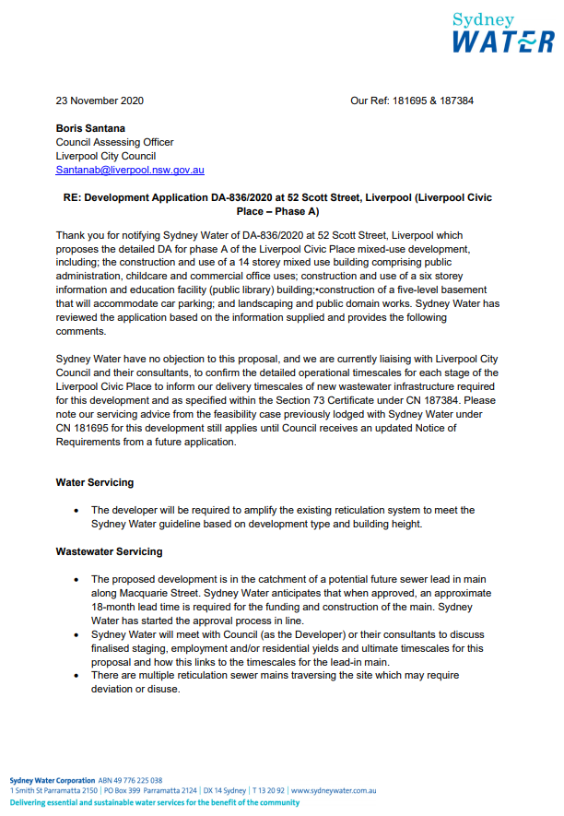
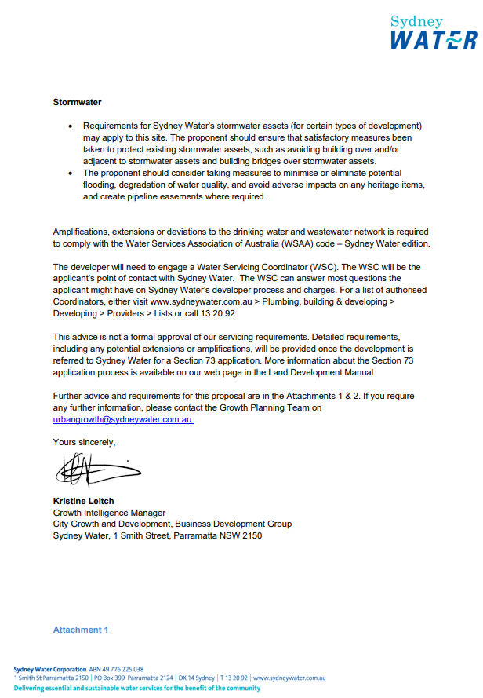
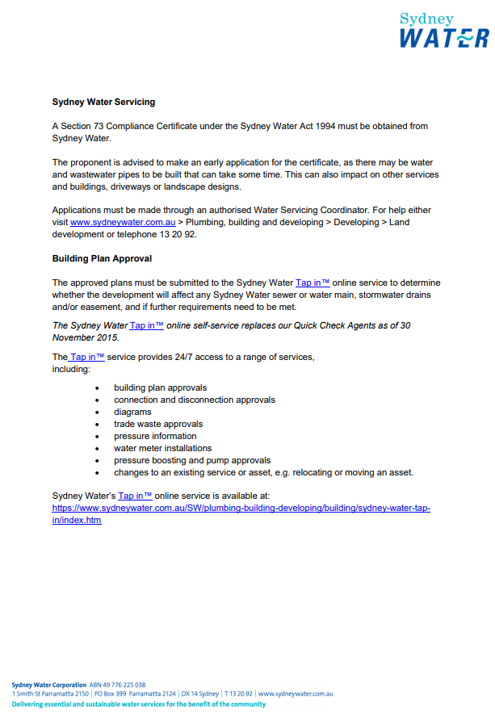
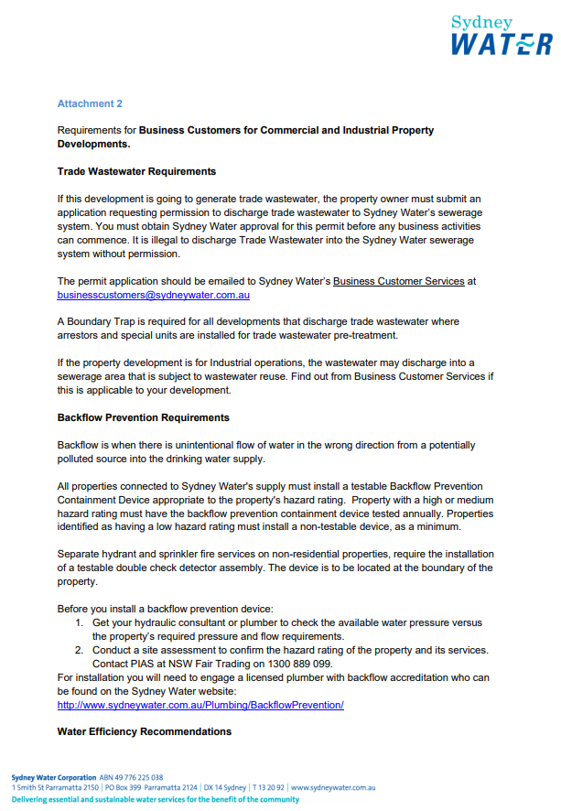
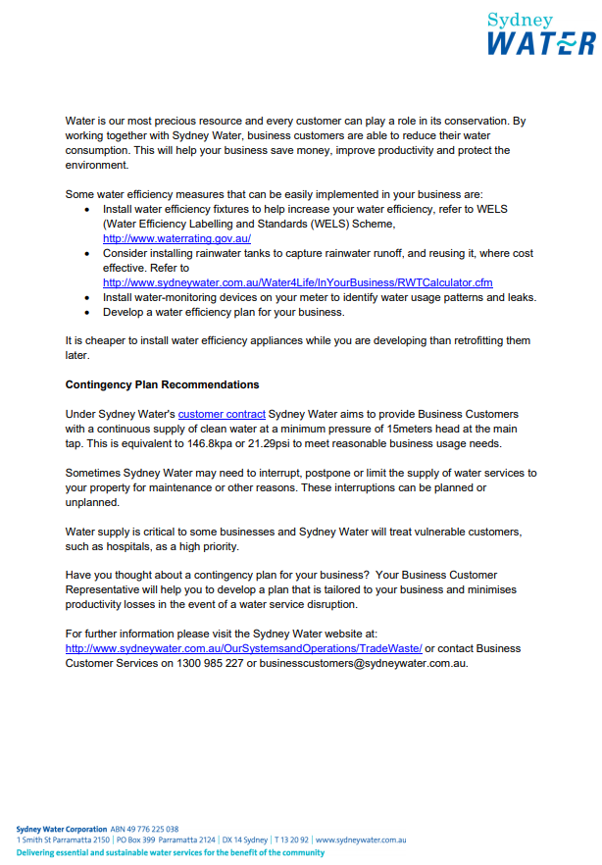

ATTACHMENT 4 – ENDEAVOUR ENERGY REQUIREMENTS
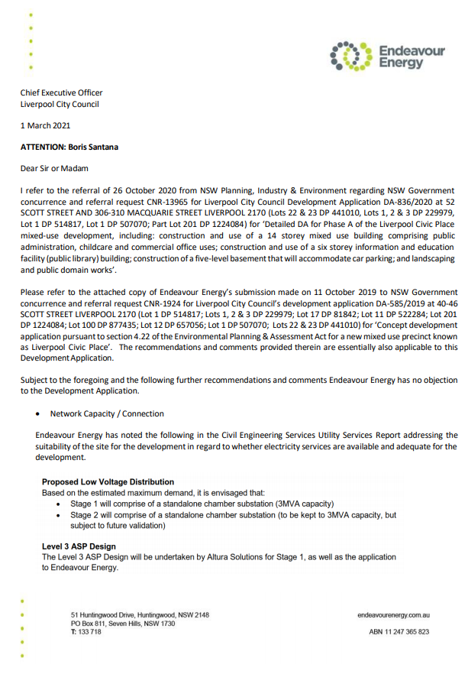
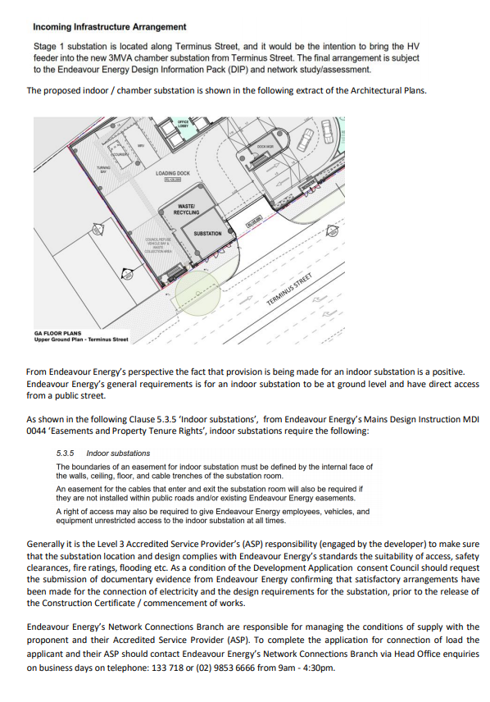
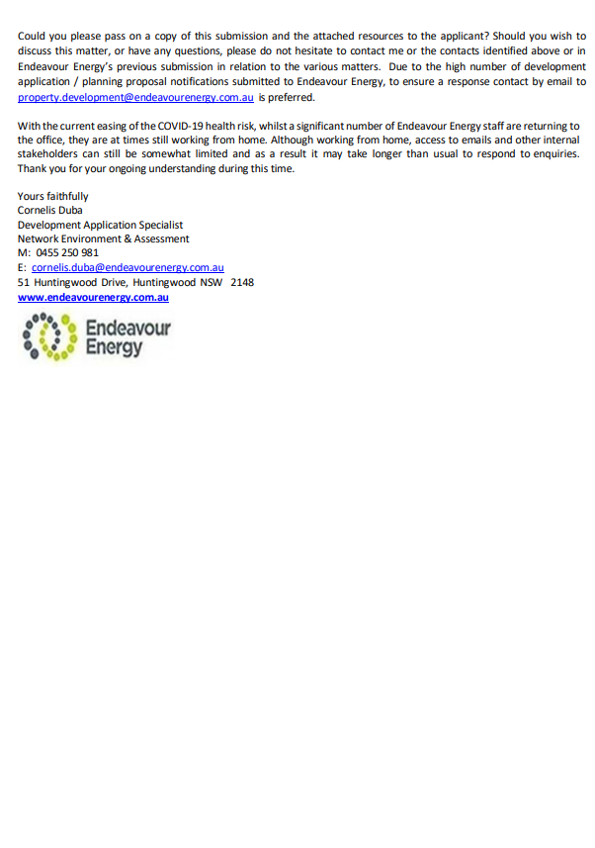

ATTACHMENT 5 – TRANSPORT FOR NSW REQUIREMENTS
